1. **Steps for creating topics from Amazon sns :-**
2. **Go to AWS console page**
3. **Search for AMAZON SNS interface page at search bar option**
4. **Then select TOPICS from left side of the page**
5. **Select create TOPICS like as shown below images**
6. **By adding some credentials at required tabs shown below**
7. **After entering all finally select create tab ..**

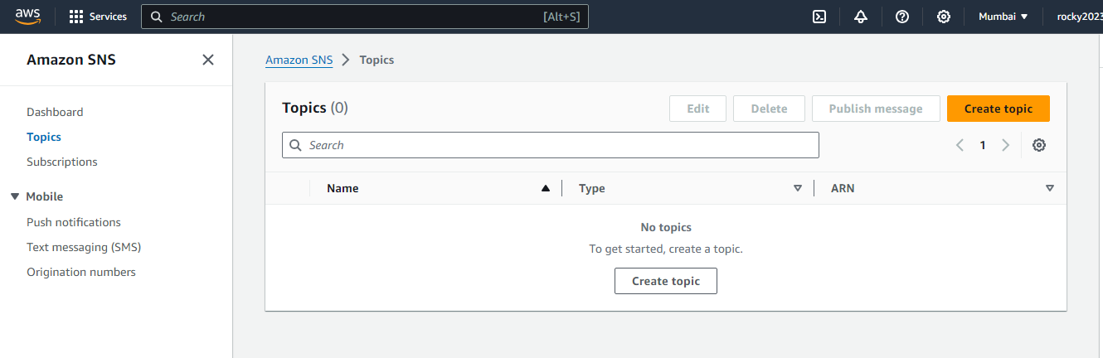**2) Step to create TOPIC :-**

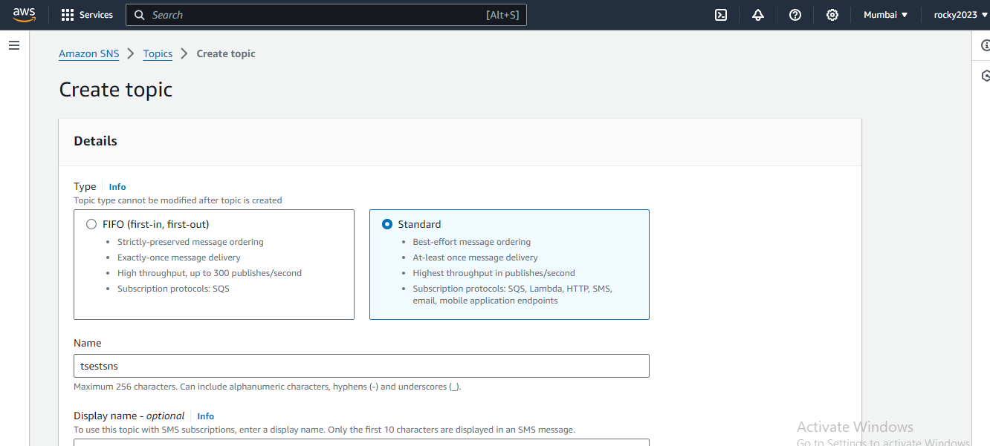

**3) After completion creating TOPICS next go to subscriptions :-**

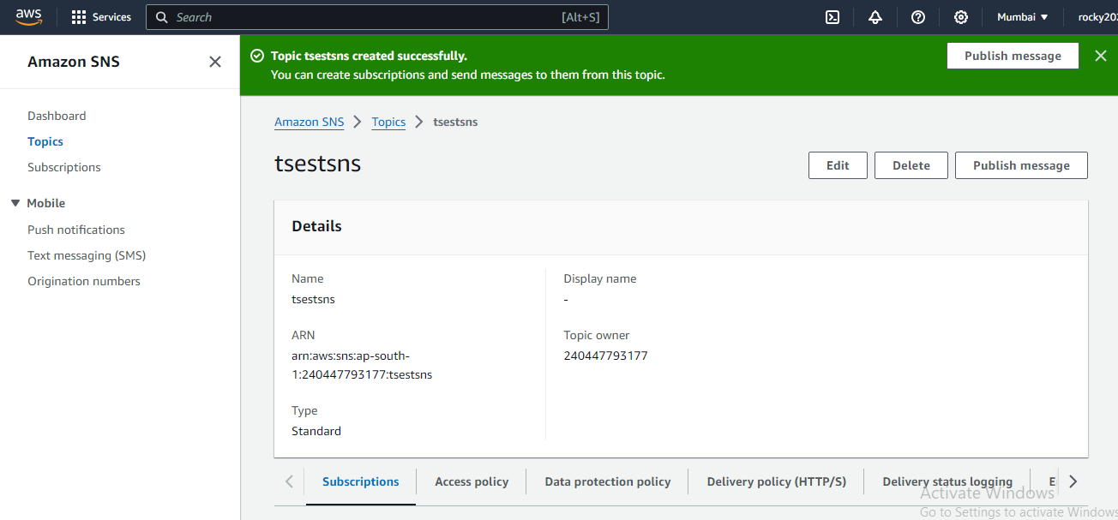

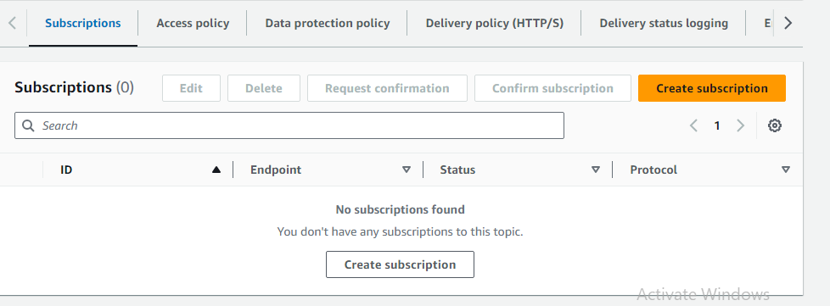

**4) After completion of subscription where ur provided ur emaild msg notification sent and in ur mail confirm subscription by clicking the link :-**

**a. Fallow the below images step wise.**

